Form Angular
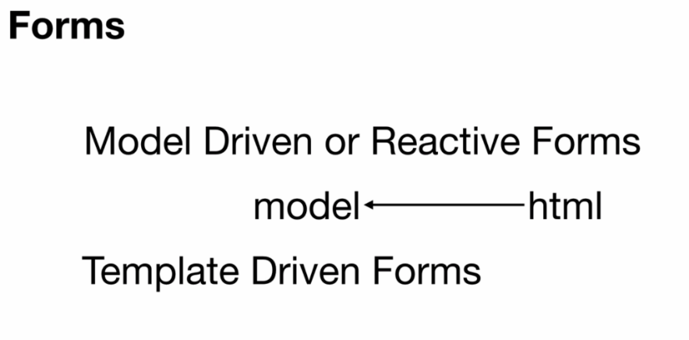

- Model Driven: we create model first then we map from the html to the model
- Model Driven or Reactive Forms : មានពីរសំខាន់គឺ FormGroup and FormControl
  - FormGroup : this is the object ដំណាង <form>
  - FormControl: is refresend <input> or element that we use in the <form>
- យើងអាចធ្វើការ Validation to these two object : FromGroup and FormCiontrol
- FormGroup is the collection of FromControl
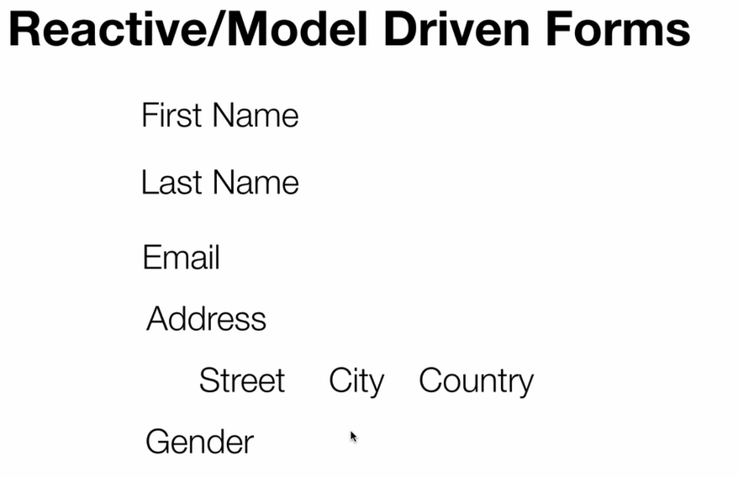

What we will do first in Reactive form or model driven forms.

- Create form
- import { FormGroup, FormControl} from '@angular/forms';

- FormGroup : កន្លែងដែលយើងបង្កើត model file យើង
- FormControl : កន្លែងបង្ហាញថា វាជា text, number, or drop box etc

- Crate FormGroup model then bind from HTML to ts
- Add ReactiveFormsModule to the app.module
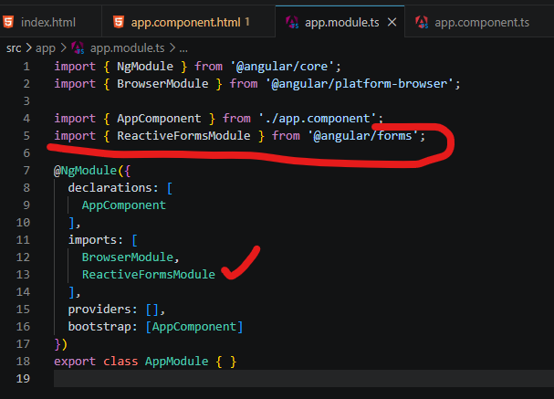

- Bind field and html
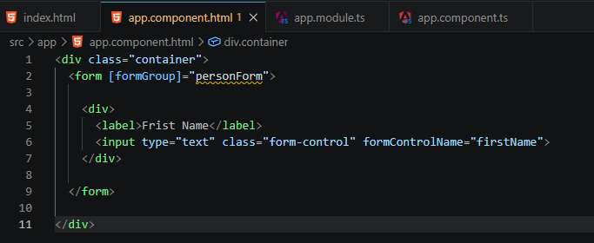

- formControlName: where we bind the filed to to the ts :
- formControlName="firstName"

- firstName: new FormControl(),

- First Name :
<div>
<label>Frist Name</label>
<input type="text" class="form-control" formControlName="firstName">
</div>

- This is the first input form that we bind from html to ts
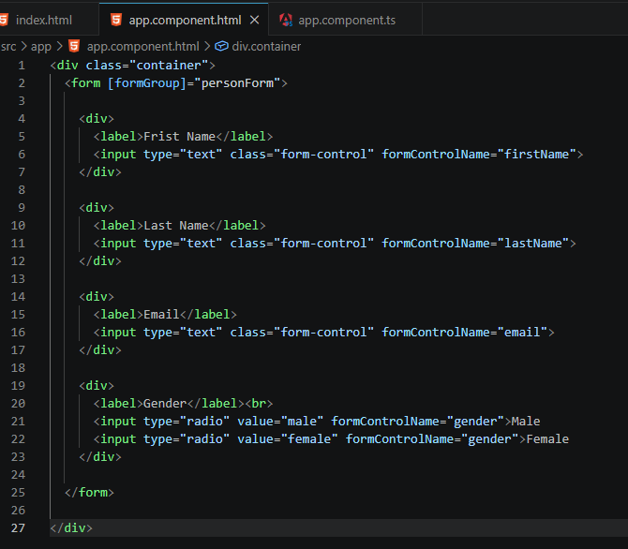

TS:
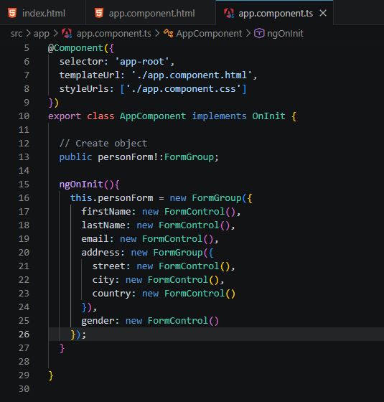

- Sub field binding
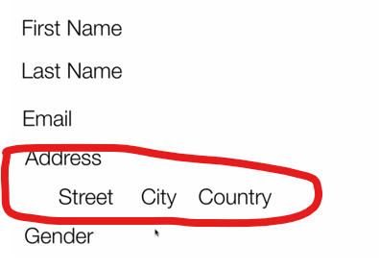

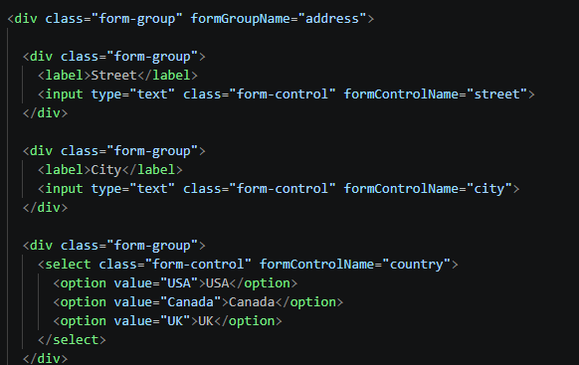

- formGroupName vs fromControlName
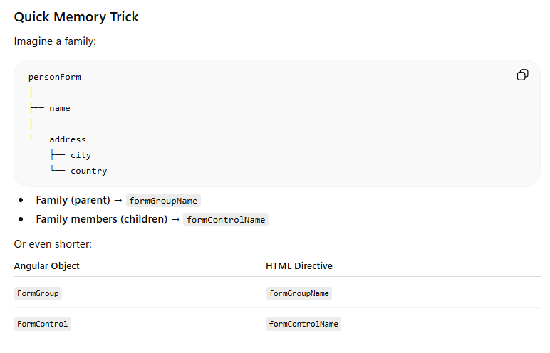

Binding remember noted:
- formGroup = "I have the actual FormGroup object"
- formGroupName = Group (Container)
- formControlName = Single Control (Input)
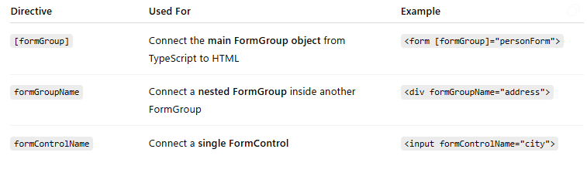

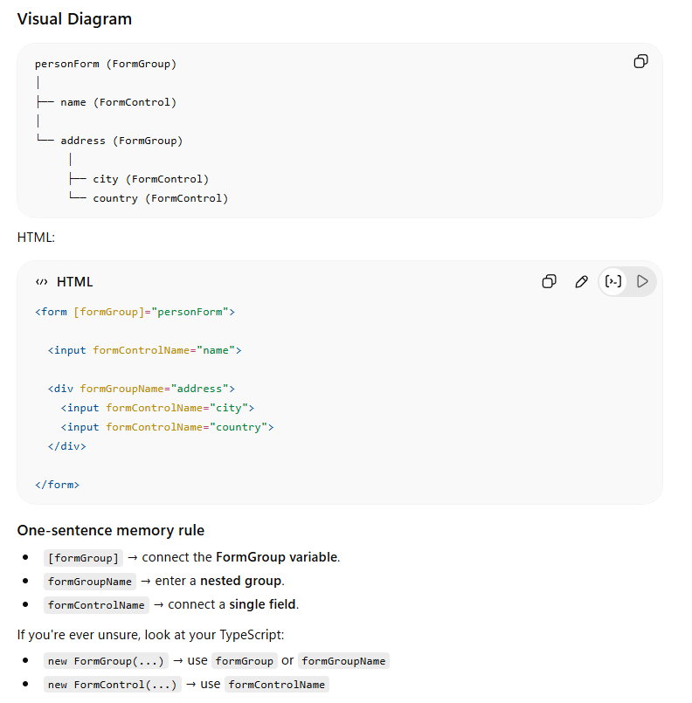

- submit button
- <form [formGroup]="personForm" (ngSubmit)="onSubmit()">
- <div>
- <input type="submit" class="btn btn-success" value="Submit">
- </div>

